**Team Budget Planner.**

**Developer Name:** DESU MONICA

This document contains contents for:

* Project Description
* Flow of the Application
* Core concepts used in project
* Conclusions

**1.Project Description:**

As a developer, write a program using JavaScript to decide the budget of a specific team.

* You need to develop a website where program managers of a specific team will add details of professional deals they want to have with vendors.
* The finance team will check expenses of those teams and will decide their annual budget.
* Versions of the code should be tracked on GitHub repositories
* Team Budget Planner should work properly

**2.Application Flow:**

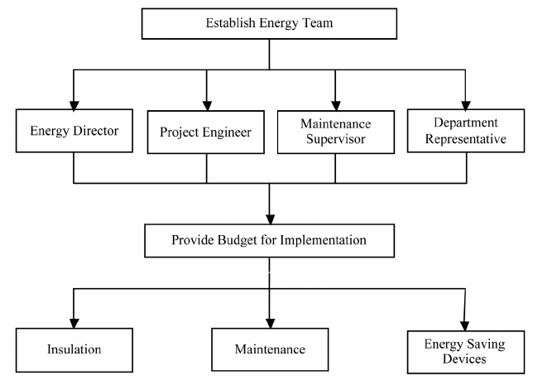

**3.Core concepts used in project:**

● Visual Studio Code: An IDE to code for the application

● JavaScript: A programming language

● Git: To connect and push files from the local system to GitHub

● GitHub: To store the application code and track its versions

● JavaScript concepts: Functions, prototypes, primitives, objects, IIFEs, promises, async, and webpack

**4.Conclusions:**

This project is designed to creating a team budget planner using java script.